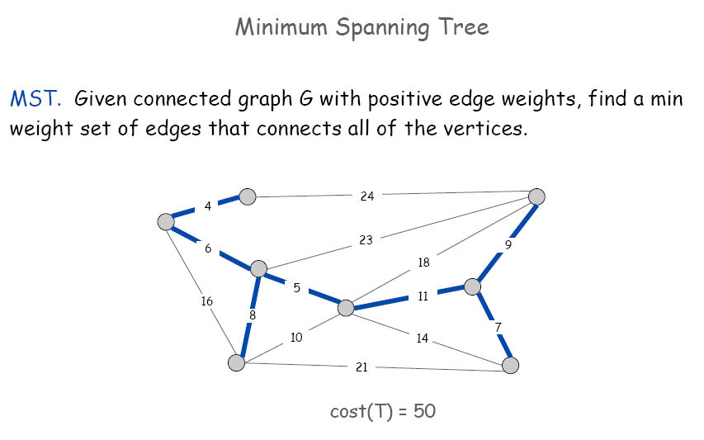
A
B
C
D
E
F
G
H

The weighted matrix is:
 | 1 | 2 | 3 | 4 | 5 | 6 | 7 | 8
1 | 0 | 4 | 0 | 6 | 0 | 0 | 16 | 0
2 | 4 | 0 | 24 | 0 | 0 | 0 | 0 | 0
3 | 0 | 24 | 0 | 23 | 18 | 9 | 0 | 0
4 | 6 | 0 | 23 | 0 | 5 | 0 | 8 | 0
5 | 0 | 0 | 18 | 5 | 0 | 11 | 10 | 14
6 | 0 | 0 | 9 | 0 | 11 | 0 | 0 | 7
7 | 16 | 0 | 0 | 8 | 10 | 0 | 0 | 21
8 | 0 | 0 | 0 | 0 | 14 | 7 | 21 | 0

